**1. Permutations**

Permutation is a way of counting ____________________. Arrangements can be items like, how winning prizes are given, who gives a speech first or second, and even voting. Because items are arranged in a particular order then repetitions are not allowed. Once an item is used, it cannot be used again.

**For example:** At a high school, the yearbook staff is made up of 10 students. How many ways can the staff elect an editor, a secretary, and a treasurer?

Using the Fundamental Counting Theorem (arrangement):

Using Permutations:

**When arrangements become more complicated then use permutations:**

**Permutations Formula:**

The number of permutations, or arrangements, of **n** total things (total to choose from) taken **r** at a time (number in group) can be calculated by the following formula:

*P*(n,r) = n*P*r =

**Permutations can be done in your calculator: MATH** →→→ **PRB** (probability),

Permutation is number **2: n*P*r**

**EXAMPLE:** Evaluate the permutations in your calculator

(1) *P*(7, 3) = 7*P*3 = in calculator:

type “n” number

(2) *P*(100, 2) = 100*P*2 = select n*P*r

type “r” number

enter

**2. Combinations**

Combination is not an arrangement or order but rather a ________________. It is usually a smaller group made from the larger group. Combination is a general group and order is not important and once again, repetitions are not allowed. Once an item is used, it cannot be used again.

**For example:** How many ways can a club of 25-members choose a committee of three members?

Using Combinations:

**Combinations Formula:**

The number of combinations, or subsets, of **n** total things (total to choose from)

taken **r** at a time (number in group) can be calculated by the following formula:

*C*(n,r) = n*C*r =

Divide by *r!* to take away duplicates of the same subsets.

**Combinations can be done in your calculator: MATH** →→→ **PRB** (probability),

Combination is number **3: n*C*r**

**EXAMPLE:** Evaluate the combinations in your calculator:

(1) *C*(10, 2) = 10*C*2 = in calculator:

type “n” number

(2) *C*(9, 4) = 9*C*4 = select n*C*r

type “r” number

enter

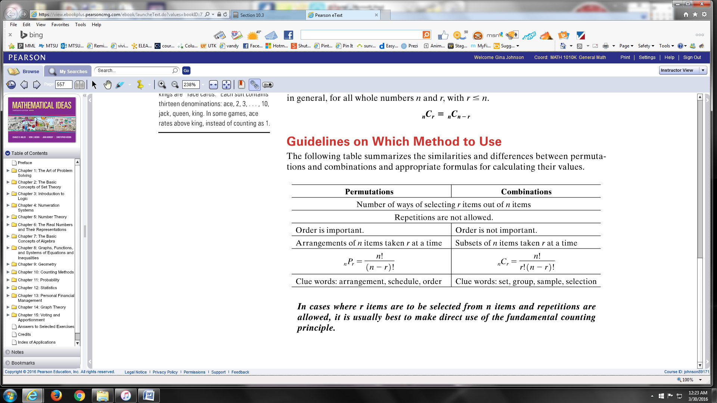

**Decide if the examples are permutations or combinations and answer the question.**

**EXAMPLE:** How many ways can first, second, and third place finishers occur in a race with 23 runners competing?

**EXAMPLE:** How many 5-member committees can be formed from 100 US Senators?

**EXAMPLE:** How many different ways can a lottery select 5 numbers from the

numbers 1-39?

**EXAMPLE:** How many ways are there to draw a 5-card hand from a 52-card deck?

**EXAMPLE:** A speech class has 8 students. How many ways can the class of students give a speech?

**EXAMPLE:** How many ways can fifteen people be divided into five groups containing one, two, three, four, and five respectively in each group?

**EXAMPLE:** Using a standard 52-card deck, how many possible 5-card hands would consist of the following cards?

1. Four clubs and one non-club:
2. Two red cards, two clubs and a spade: